🚀 Creating a Microsoft Purview Account with Python SDK

This project demonstrates how to programmatically create a Microsoft Purview account using the Azure Python SDK.

📋 Prerequisites
Before running the script, ensure you have:
- An Azure subscription
- A Service Principal with Contributor/Owner role on the subscription
- The Microsoft.Purview resource provider registered on the subscription

The following details are required during the Creation of purview account:
- Tenant ID
- Subscription ID
- Service Principal Client ID
- Service Principal Secret Value
- Resource Group Name (existing or new)
- Region (for both Resource Group and Purview account)

## 1️⃣ Run the Script
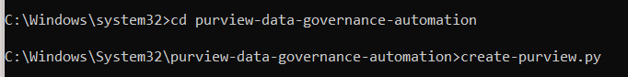
Open your terminal or IDE and execute:
```bash
create_purview.py
```

You will be prompted to enter:
- Tenant ID
- Subscription ID
- Service Principal Client ID
- Service Principal Secret Value
- Resource Group Name
- Purview Account Name (must be globally unique)
- Region
## 2️⃣ Resource Group Creation

- If the specified resource group does not exist, the script will automatically create it.

## 3️⃣ Purview Account Provisioning

- The script provisions a Purview account with **System-assigned identity** and **Standard SKU with 1 capacity unit**.
- The provisioning state will be checked every 30 seconds until it reaches `Succeeded`.
## 4️⃣ Successful Creation Output

Once complete, you’ll see details such as:
Location: eastus Name: mypurviewdemo
ID: /subscriptions/xxxx/resourceGroups/demo-rg/providers/Microsoft.Purview/accounts/mypurviewdemo
Tags: {}
Creating
Creating
Succeeded
## 5️⃣ Verify in Azure Portal
Navigate to the **Azure Portal → Purview Accounts** to confirm the new account is listed.

